Datatypes returned for column 1 values

Function ka type is returned as an object function

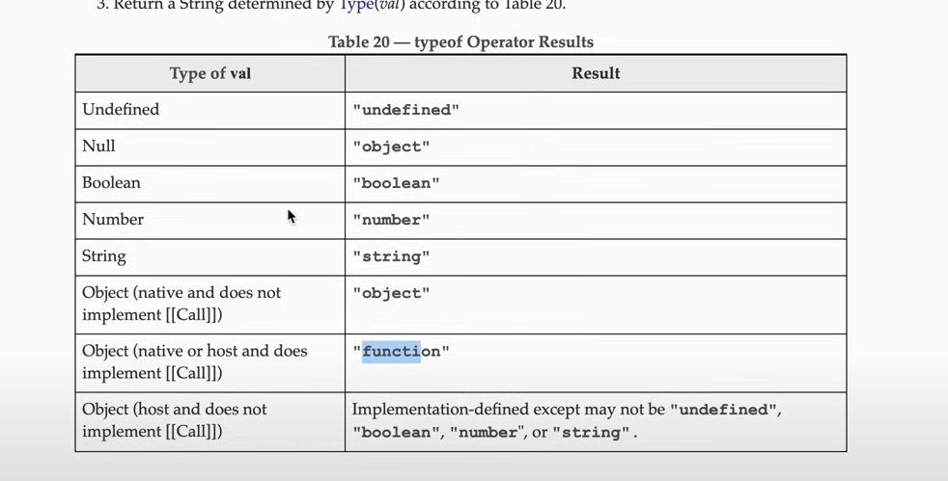

2. 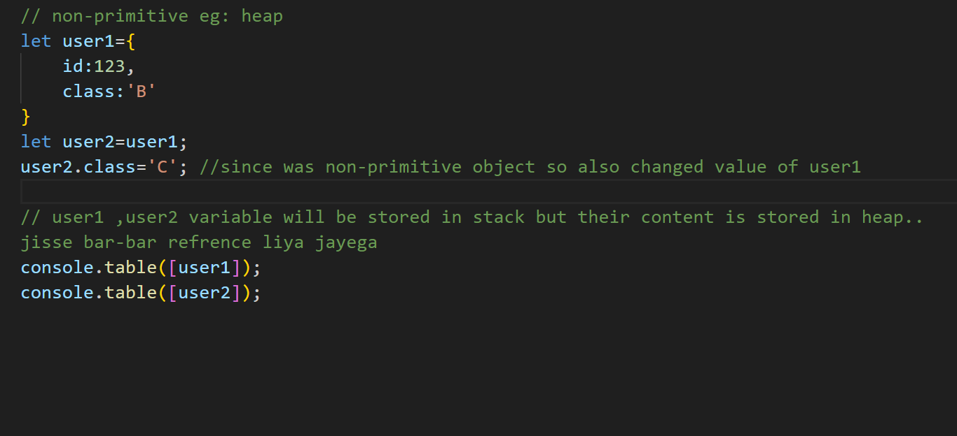

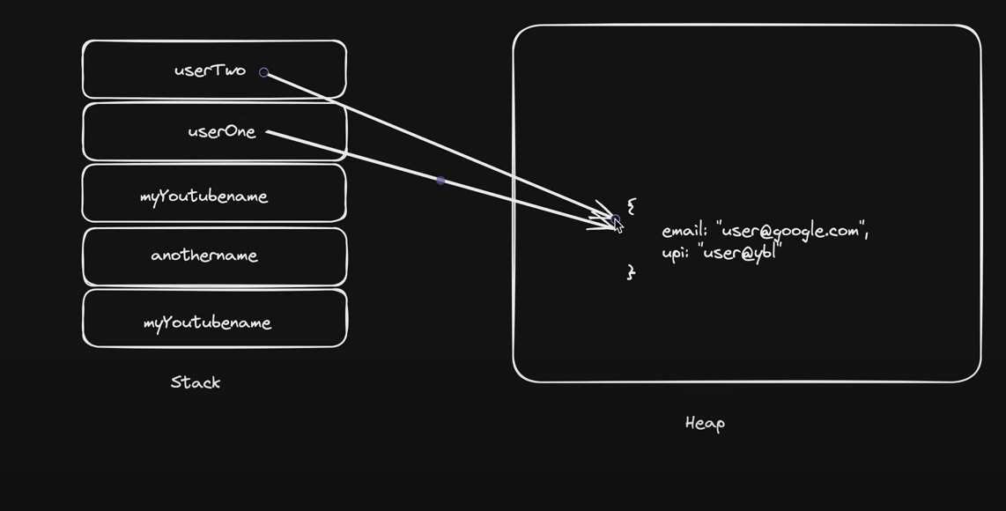

3. string is always an object and not a character array like in cpp. a string has key-value pairs in js like an object..the keys are indexes of cahracters

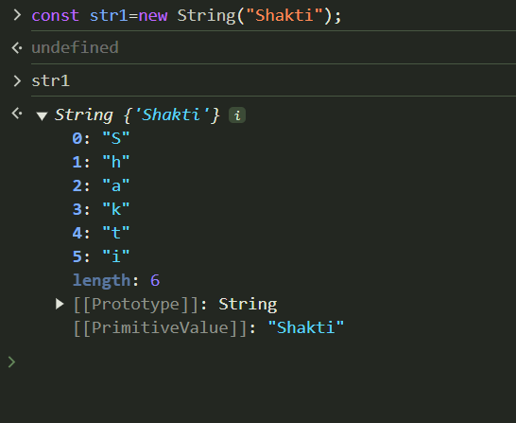

The prototype includes all the methods that can be used with the string in javascript:  
